Alpine veg air photo analysis update
Peter Vesk April 17 2015
I have resumed working on the analyses of the air photo data provided by Keith McDougal. These consist of counts in classes of vegetation from grids of 1600 points (400 x 400) overlaying air photos. The classes are Woodland, Shrubland, grassland and Other (wetland?)
There are 3 series of photographs: one for each of 23 areas from somewhere in the ~1940’s, 1970’s and 2000s.
The aims as I understand them are: to determine how vegetation has changed over time; which vegetation types may have increased or decreased; how the vegetation dynamics are influenced by clearing and burning activities, wildfires, and livestock grazing and its removal.
The first step has been to model one veg class at a time. Because there are only three points in time for any photo scene, any model has to be extremely simple. Single parameter growth models like exponential growth are unlikely to useful, as we know unbounded growth cannot occur. If for nothing else other than the scene is bounded. No class can occupy more than 1600 points.
Previously I have attempted to analyse one vegetation class at a time. I have now made a couple of advances:
- fitting a Poisson regression to all three classes simultaneously,
This leads to good fit to the data, and shows that trees are generally increasing
This has the disadvantage of not being a very good process model. Specifically, when one ‘simulates’ a time course, by plotting predictions of the ~60 years spanned by the data series, the growth rates are not appreciably changed. Here are some results:

The first figure just presents data as cumulative proportions across 3 vegetation types (Woodland, Shrubland, Grassland). It shows the proportional change across the sites for the 3 veg types: Grassland in Grey, then Black is Grassland + Shrubland; the reamiander above the black line is woodland. So you can see the grassland is declining, the woodland is expanding, shrubs are somewhere in the middle: they are increasing a little.

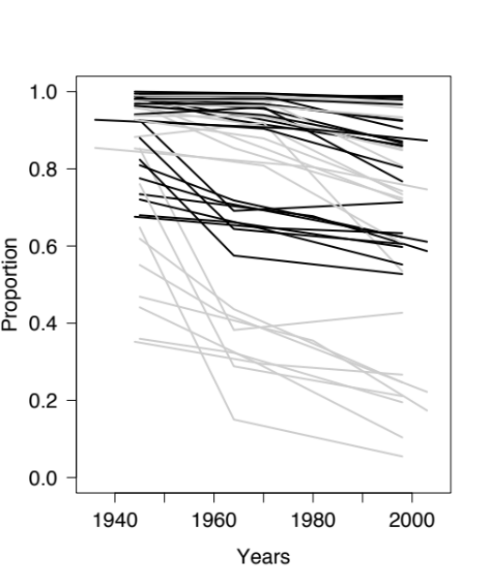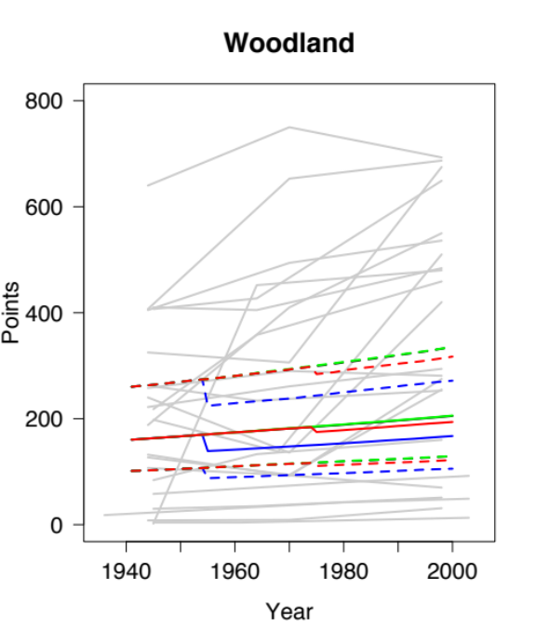
These next figures present one veg type at a time. Background light grey are the observations. Colours are the modeled trajectories: Blue is effect of clearing and burning in 1955. Red is effect of wildfire in 1975. Green is effect of removing grazing in 1964. Black, at bottom is base case: continued grazing, no other disturbances.
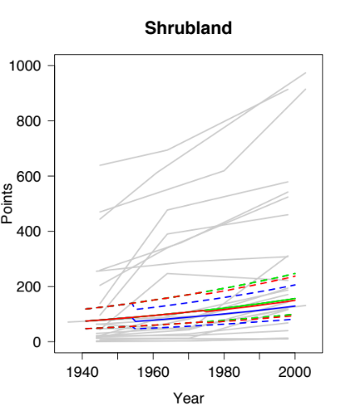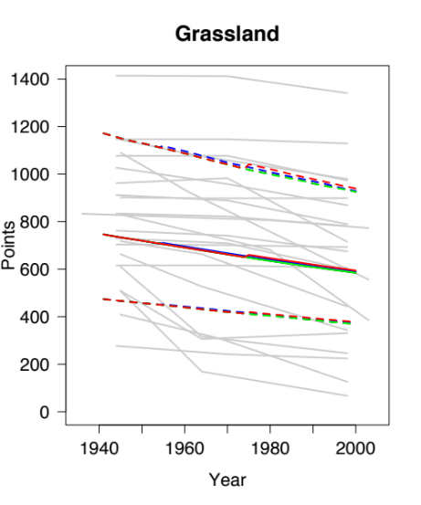
The parameter estimates appear below. Veg type 1 is woodland, 2 is Shrubland and 3 is Grassland.
These tell us that on average, the most common veg is grassland then woodland, then shrubland.
B, the slope of change is greatest for shrubs (increasing), increase in woodland is about 1/3 that rate, but pretty uncertain, while grassland is decreasing at about the same rate as woodland, but with much greater certainty.
Grazing removal increases woodland, but has no effect on shrubland or grassland.
Fires reduce woodland, may reduce shrublands, but it is uncertain and likewise, grassland may be increased by fire, but it is uncertain.
The clearing/burning effects are confusing me at present. The parameter means the effect of they say woodlands and shrublands are increased substantially by clearing/burning. Part of the problem, is that I don’t know when the clearing occurred.
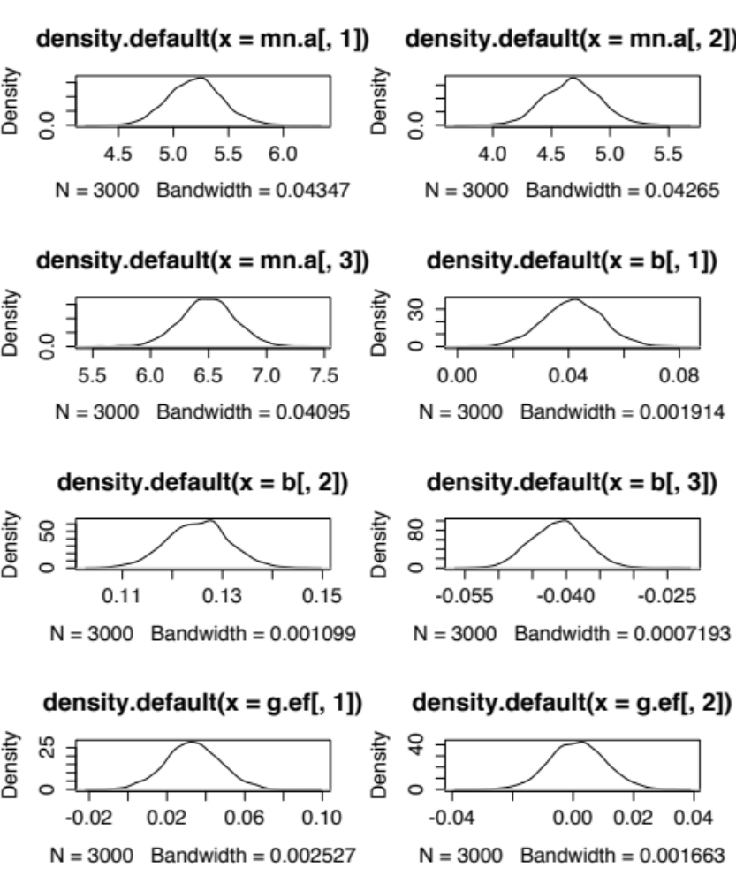
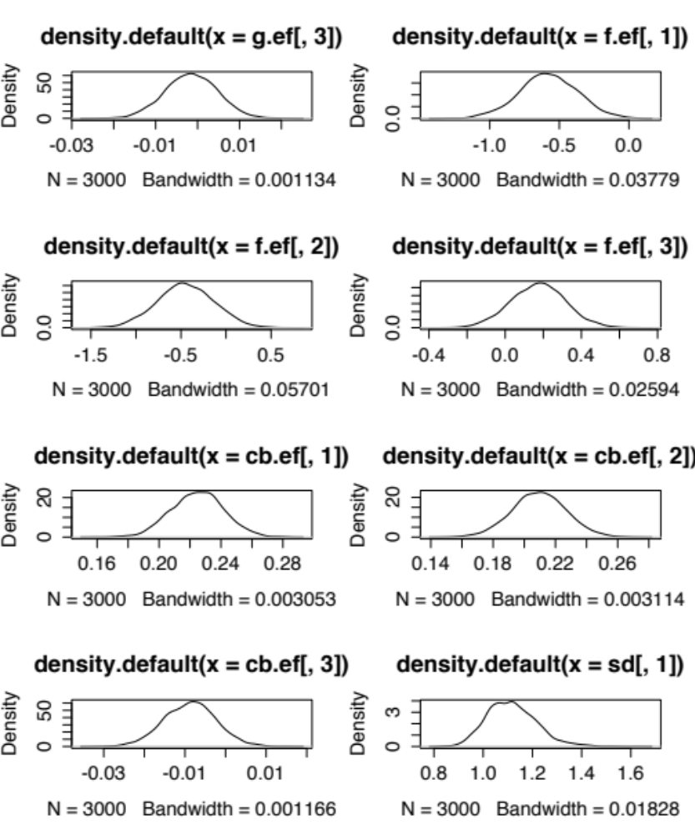

The next figures present predicted vs observe values for each of the 3 veg types. You can see that the model predicts the observations pretty well. That is I could reproduce the photo series.

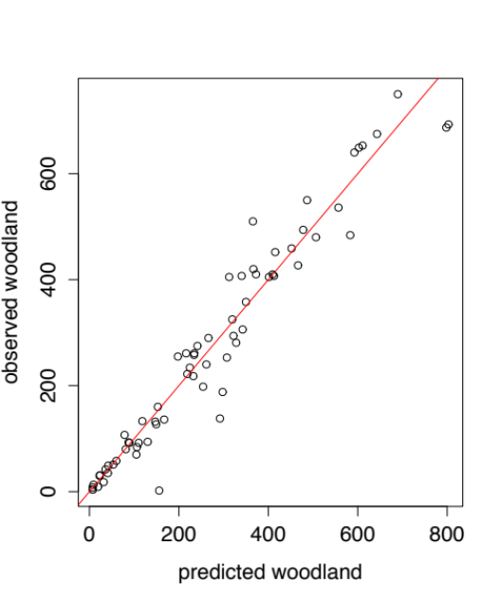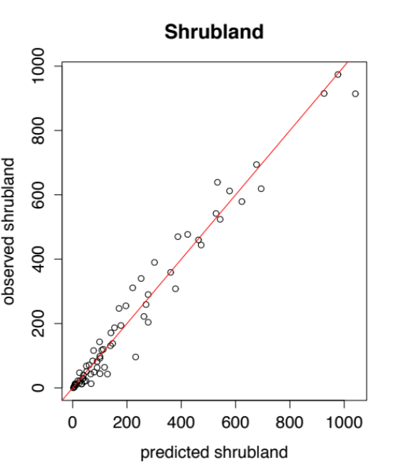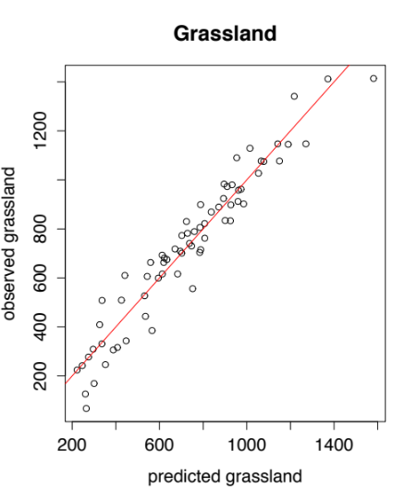

But as a process model, that reproduces a sensible time-course of veg dynamics (see first set of figs, especially woodland), this model is not so good. What you see is a crash in cover after clearing event, but with no increase in growth rate and then slowing as it approaches ‘equilibrium’ carrying capacity. This is because the disturbance events (clearing and wildfire) are affecting the intercept, but the grazing removal affects the slope.
For this reason I have investigated fitting logistic growth equations, specifically a Ricker model. This fits a density dependent growth rate = exp(Ro * (1 –N/K)) so when N is small the growth rate is maximal (and approaches Ro, the maximum intrinsic growth rate) but as N approaches K, the carrying capacity, the population growth rate slows to 0, and if N>K then population growth rate is <0. But this model is rather tricky to fit, so this is work in progress. I can get it to work, but I’m still thinking through how best to handle the covariates (disturbances) and any possible competition between the veg types.
Anyway, just wanted to update you and to suggest a chat some time to work through some of the problems. I have since used 4 veg types in the Ricker model (the remainder being wetland???) because that helps to constrain the model. I haven’t done this for the Poisson regression model.
Specific questions: what does the clear-burn variable mean? Is it the % of woodland thought cleared and burnt? But what about shrubs? Weren’t the cleared and burnt? When is it thought to have occurred?
What is the remainder? Is it a coherent vegetation type, that could and maybe should be modeled?
What exactly are the questions? This matters for which model we fit.
I’m

